**Practical Exercises**

* 1. Label and identify different sections and components on the diagram below

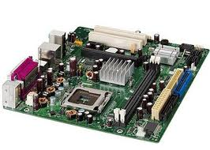

……………………………………………………………………………………………………………………………………………………………………………………………………………………………………………………………………………………………………………………………………………………………………………………………………………………………………………………………………………………………………………………………………………………………………………………………………………………………………………………………………………………………………………………………………………………………………………………………………………………………………………………………………………………………………………………………………………………………………………………………………………………………………………………………………………………………………………………………………………………………………………………………………………………………………………………………………………………………………………………………………………………………………………………………………………………………………………………………………………………………………………………………………………………

* 1. Label, identify and explain the uses of the ports on the diagram below

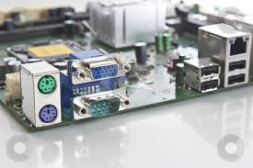

……………………………………………………………………………………………………………………………………………………………………………………………………………………………………………………………………………………………………………………………………………………………………………………………………………………………………………………………………………………………………………………………………………………………………………………………………………………………………………………………………………………………………………………………………………………………………………………………………………………………………………………………………………………………………………………………………………………………………………………………………………………………………………………………………………………………………………………………………………………………………………………………………………………………………………………………………………………………………………………………………………………………………………………………………………………………………………………………………………………………………………………………………………………………………………………………………………………………………………………………………………………………………………………………………………………………………………………………………………………………………………………………………………………………………………………………………………………………………………………………………………………………………………………………………………………………………………………………………

* 1. With your knowledge of Logic gates, design a computer with three processors. The computer can handle **SIMPLE TASK** any time the **first processor (P1)** is **ON** and others are **OFF** or the **second processor** **(P2)** is **ON** and others are **OFF** or the **third processor** **(P3)** is **ON** and others are **OFF**. The computer can handle **BIGGER TASKS** any time the first **(P1)** and second processors **(P2)** are **ON** and the third **(P3)** is **OFF** or when all of them **P1, P2** and **P3** are **ON**. Design a TRUTH TABLE and draw the components of the processor.

……………………………………………………………………………………………………………………………………………………………………………………………………………………………………………………………………………………………………………………………………………………………………………………………………………………………………………………………………………………………………………………………………………………………………………………………………………………………………………………………………………………………………………………………………………………………………………………………………………………………………………………………………………………………………………………………………………………………………………………………………………………………………………………………………………………………………………………………………………………………………………………………………………………………………………………………………………………………………………………………………………………………………………………………………………………………………………………………………………………………………………………………………………………………………………………………………………………………………………………………………………………………………………………………………………………………………………………………………………………………………………………………………………………………………………………………………………………………………………………………………………………………………………………………………………………………………………………………………………………………………………………………………………………………………………………………………………………………………………………………………………………………………………………………………………………………………………………………………………………………………………………………………………………………………………………………………………………………………………………………………………………………………………………………………………………………………………………………………………………………………………………………………………………………………………………………………………………………………………………………………………………………………………………………………………………………………………………………………………………………………………………………………………………………………………………………………………………………………………………………………………………………………………………………………………………………………………………………………………………………………………………………………………………………………………………………